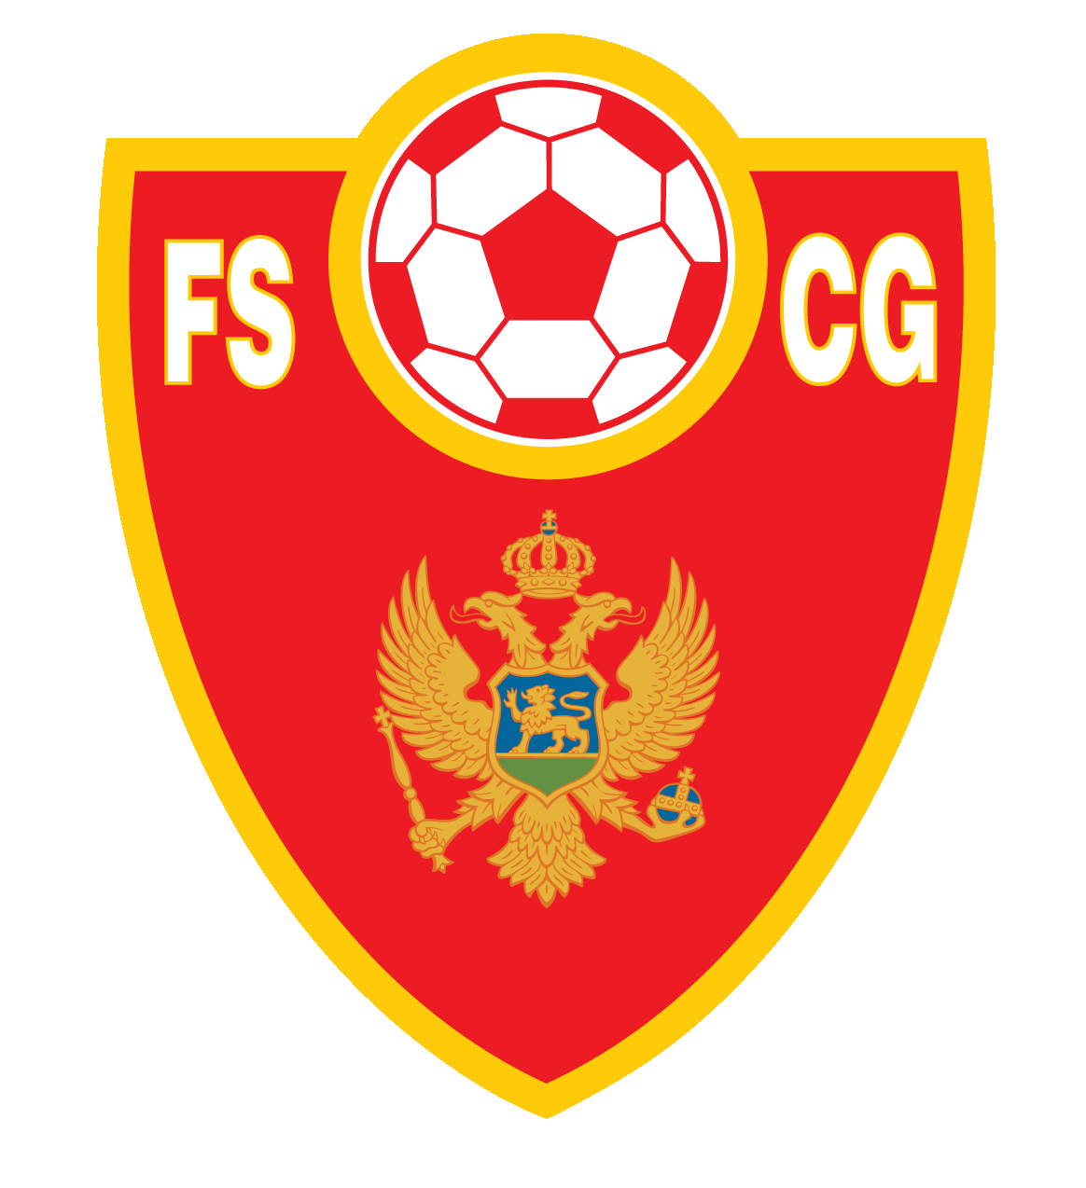

**CENTAR ZA EDUKACIJU TRENERA FSCG**

**SPISAK FUDBALSKIH TRENERA SA UEFA C DIPLOMOM**

|  |  |  |  |  |  |  |  |  |  |  |  |  |
| --- | --- | --- | --- | --- | --- | --- | --- | --- | --- | --- | --- | --- |
| # | Ime i prezime |  | Broj licence | Datum rođenja | Mjesto rođenja |  | Zvanje | | Položio | | Važi do | |
| 1 | **Filip** | **Vukčević** | **0003** | 24.11.1998. | Podgorica | UEFA C diploma | | 24.11.2022. | | 31.12.2025. | |
| 2 | **Milivoje** | **Grbović** | **0004** | 28.03.1994. | Podgorica | UEFA C diploma | | 29.11.2022. | | 31.12.2025. | |
| 3 | **Milan** | **Lalić** | **0005** | 12.04.1997. | Cetinje | UEFA C diploma | | 03.12.2022. | | 31.12.2025. | |
| 4 | **Mišo** | **Vukoje** | **0006** | 19.08.1982. | Mostar | UEFA C diploma | | 27.02.2023. | | 31.12.2025. | |
| 5 | **Marko** | **Peričić** | **0007** | 31.01.2001. | Beograd | UEFA C diploma | | 27.02.2023. | | 31.12.2025. | |
| 6 | **Aleksei** | **Shchukin** | **0008** | 22.04.1980. | Astrakhan | UEFA C diploma | | 27.02.2023. | | 31.12.2025. | |
| 7 | **Niša** | **Dmitrović** | **0009** | 08.06.1996. | Podgorica | UEFA C diploma | | 29.11.2022. | | 31.12.2025. | |
| 8 | **Milan** | **Đokić** | **0010** | 10.03.1981. | Podgorica | UEFA C diploma | | 17.03.2023. | | 31.12.2025. | |
| 9 | **Miraš** | **Dukić** | **0011** | 24.05.1997. | Podgorica | UEFA C diploma | | 17.03.2023. | | 31.12.2025. | |
| 10 | **Boris** | **Bošković** | **0012** | 05.03.1987. | Podgorica | UEFA C diploma | | 20.04.2023. | | 31.12.2025. | |
| 11 | **Ognjen** | **Raičković** | **0014** | 30.09.2001. | Bačka Topola | UEFA C diploma | | 11.08.2023. | | 31.12.2025. | |
| 12 | **Vladimir** | **Slović** | **0015** | 12.09.1981. | Zenica | UEFA C diploma | | 04.07.2023. | | 31.12.2025. | |
| 13 | **Arslan** | **Dacić** | **0016** | 25.08.1982. | Rožaje | UEFA C diploma | | 11.08.2023. | | 31.12.2025. | |
| 14 | **Pavle** | **Bošković** | **0017** | 18.01.1990. | Podgorica | UEFA C diploma | | 31.08.2023. | | 31.12.2025. | |
| 15 | **Marko** | **Vukotić** | **0018** | 20.11.2000. | Cetinje | UEFA C diploma | | 31.08.2023. | | 31.12.2025. | |
| 16 | **Andrija** | **Bakrač** | **0019** | 28.01.1995. | Nikšić | UEFA C diploma | | 31.08.2023. | | 31.12.2025. | |
| 17 | **Igor** | **Simonović** | **0020** | 08.02.1984. | Cetinje | UEFA C diploma | | 15.09.2023. | | 31.12.2025. | |
| 18 | **Dejan** | **Pejović** | **0021** | 04.06.1990. | Mojkovac | UEFA C diploma | | 05.10.2023. | | 31.12.2026. | |
| 19 | **Ivana** | **Čađenović** | **0022** | 15.09.1991. | Podgorica | UEFA C diploma | | 06.10.2023. | | 31.12.2026. | |
| 20 | **Uroš** | **Smolović** | **0023** | 28.09.1992. | Podgorica | UEFA C diploma | | 24.10.2023. | | 31.12.2026. | |
| 21 | **Milić** | **Globarević** | **0024** | 14.04.1996. | Podgorica | UEFA C diploma | | 27.12.2023. | | 31.12.2026. | |
| 22 | **Dimitrije** | **Nikčević** | **0025** | 07.02.1986. | Nikšić | UEFA C diploma | | 12.01.2024. | | 31.12.2026. | |
| 23 | **Marko** | **Bakrač** | **0026** | 13.07.1982. | Nikšić | UEFA C diploma | | 12.01.2024. | | 31.12.2026. | |
| 24 | **Vido** | **Sjekloća** | **0027** | 13.12.1985. | Nikšić | UEFA C diploma | | 24.10.2023. | | 31.12.2026. | |
| 25 | **Luka** | **Vuković** | **0028** | 01.02.1997. | Cetinje | UEFA C diploma | | 22.09.2023. | | 31.12.2026. | |
| 26 | **Dejan** | **Rolović** | **0029** | 14.12.1987. | Podgorica | UEFA C diploma | | 02.04.2024. | | 31.12.2026. | |
| 27 | **Vladan** | **Mijović** | **0030** | 23.09.1992. | Podgorica | UEFA C diploma | | 14.03.2024. | | 31.12.2026. | |
| 28 | **Bojan** | **Giljen** | **0031** | 28.09.1987. | Nikšić | UEFA C diploma | | 02.04.2024 | | 31.12.2026. | |
| 29 | **Siniša** | **Stanišljević** | **0032** | 02.03,1989. | Banja Luka-BIH | UEFA C diploma | | 10.04.2024. | | 31.12.2026. | |
| 30 | **Dino** | **Međedović** | **0033** | 13.06.1989. | Sarajevo-BIH | UEFA C diploma | | 10.04.2024. | | 31.12.2026. | |
| 31 | **Aleksandar** | **Braić** | **0034** | 19.02.1985. | Cetinje | UEFA C diploma | | 20.04.2024. | | 31.12.2026. | |
| 32 | **Davor** | **Franović** | **0035** | 22.12.1977. | Kotor | UEFA C diploma | | 20.04.2024. | | 31.12.2026. | |
| 33 | **Marko** | **Hunić** | **0036** | 16.03.1989. | Kotor | UEFA C diploma | | 17.04.2024. | | 31.12.2026. | |
| 34 | **Bojan** | **Kovačević** | **0037** | 19.04.1991. | Kotor | UEFA C diploma | | 17.04.2024. | | 31.12.2026. | |
| 35 | **Samir** | **Ličina** | **0038** | 22.02.1992. | Kotor | UEFA C diploma | | 17.04.2024. | | 31.12.2026. | |
| 36 | **Alen** | **Poljak** | **0039** | 16.09.1993. | Bijelo Polje | UEFA C diploma | | 17.05.2024, | | 31.12.2026. | |
| 37 | **Siniša** | **Šegrt** | **0040** | 19.06.1975. | Trebinje-BIH | UEFA C diploma | | 14.06.2024 | | 31.12.2026. | |
| 38 | **Srđan** | **Kuljić** | **0041** | 29.04.1979. | Sarajevo - BIH | UEFA C diploma | | 14.06.2024. | | 31.12.2026. | |
| 39 | **Miodrag** | **Koprivica** | **0042** | 09.04.1990. | Kotor | UEFA C diploma | | 29.06.2024. | | 31.12.2026. | |
| 40 | **Lazar** | **Mićunović** | **0043** | 27.10.1990. | Cetinje | UEFA C diploma | | 3.07.2024 | | 31.12.2026. | |
| 41 | **Aleksandar** | **Raičković** | **0044** | 29.01.1993. | Podgorica | UEFA C diploma | | 8.07.2024. | | 31.12.2026. | |
| 42 | **Đorđe** | **Luketa** | **0045** | 06.05.1994. | Bar | UEFA C diploma | | 13.08.2024. | | 31.12.2026. | |
| 43 | **Lazar** | **Radulović** | **0046** | 05.04.1984. | Podgorica | UEFA C diploma | | 13.08.2024, | | 31.12.2026. | |
| 44 | **Nemanja** | **Ćorović** | **0047** | 26.10.1975. | Zadar | UEFA C diploma | | 29.06.2024 | | 31.12.2026. | |
| 45 | **Miloš** | **Vukić** | **0048** | 08.10.1884. | Cetinje | UEFA C diploma | | 3.07.2024. | | 31.12.2026. | |
| 46 | **Branislav** | **Stijepović** | **0049** | 23.07.1885. | Nikšić | UEFA C diploma | | 27.08.2024. | | 31.12.2026. | |
| 47 | **Bojan** | **Terzić** | **0050** | 23.08.1996. | Podgorica | UEFA C diploma | | 27.08.2024 | | 31.12.2026. | |
| 48 | **Bojan** | **Mugoša** | **0051** | 02.01.1996. | Podgorica | UEFA C diploma | | 8.07.2024. | | 31.12.2026. | |
| 49 | **Velibor** | **Mršulja** | **0052** | 18.06.1991. | Kotor | UEFA C diploma | | 17.04.2024. | | 31.12.2026. | |